Landforms

Fjords | Horn | Talus
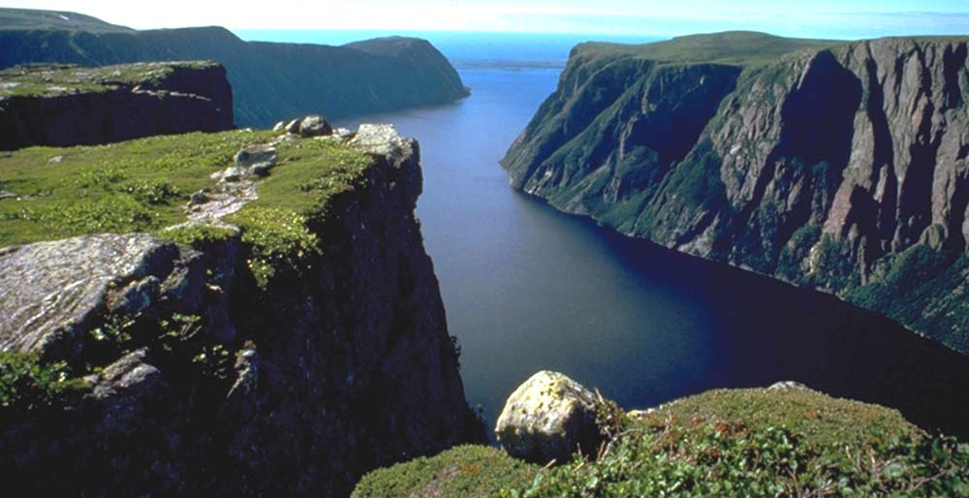 | PIC | 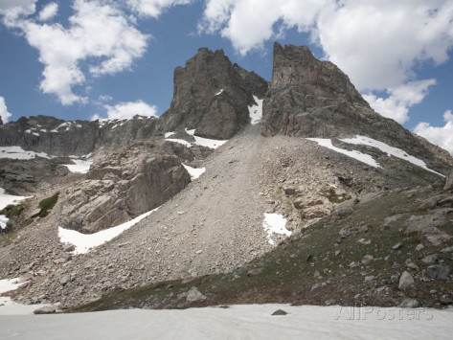
Landform | Landform | Landform
PIC | PIC | PIC
Landform | Landform | Landform
PIC | PIC | PIC
Landform | Landform | Landform
PIC | PIC | PIC
Landform | Landform | Landform
PIC | PIC | PIC

