**Exploring Technology 10**

**“What’s Wrong With This Picture?”**

1. The following draft drawing would earn you an INC in EXP10. Using the space below, list at least 10 things that would need to be improved for this to be even CONSIDERED to be graded.

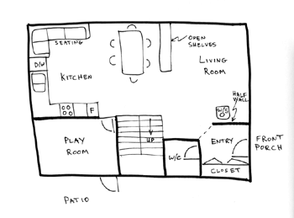

1. __________________________________________________________________
2. __________________________________________________________________
3. __________________________________________________________________
4. __________________________________________________________________
5. __________________________________________________________________
6. __________________________________________________________________
7. __________________________________________________________________
8. __________________________________________________________________
9. __________________________________________________________________
10. ____________________________________________________________
11. Next, CORRECT the drawing. You must include:
    1. DIMENSIONS – please follow the conventions for drawing dimension lines. Use REALISTIC dimensions (outside dimensions might be something like 20’x25’ – take it from there)
    2. SCALE – dimensions can be as accurate as you like. It counts for nothing if it’s not done to scale.
    3. STRAIGHT LINES (where appropriate) – this means you need a straight edge. Sloppy doesn’t cut it. Period.
    4. CORRECT SYMBOLS
    5. PLAIN PAPER (or graph paper) – wrinkled edges and stray marks, finger prints, boogers, food stains, whatever, will not be accepted. Period.